CANYON PARK NEWS
Home of the Knights
December 18, 2020 Vol. 17

Wishing you a Happy Holiday
A Note from our Mental Health Therapist
Need Assistance? Can you Help?
Second Semester Distribution Day
Winter Break Numerade Courses
Washington Listens Provides Free Support
Thank you Art Students
Counseling Connections
Contact Information
PTSA

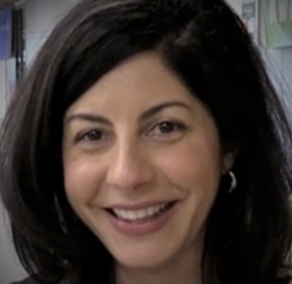

wishing you a Happy Holiday

Thank you to all families, staff, and students who joined us for this week’s CPMS/PTSA Community Night. We hope this evening provided you with some information to move forward into 2021, assist your child and family in ways to cope and flourish in the remote learning setting, and allowed for a supportive space to connect with our counseling team. We know time is valuable, and we are planning on continuing these series of Community Nights.

A big shout out to our PTSA leaders who helped craft this evening into a place for members to decompress. PTSA also supported the evening with the event design, organization, communication, and technology. Our PTSA Rocks!

Feedback is the breakfast of champions! We need it from those who attended and those who could not join us for the evening. Please fill out this form and we will use your essential feedback to create more powerful events and experiences relevant to you and your family’s needs: Community Night Survey

The video will be uploaded to our Schoology page- please use Clever to log in.

The break is upon us, I encourage you to connect as a family as much as you are able to (see Lindsey’s and our Counselor’s lists), create the most of the time you have together and form powerful memories. We know many of our students will be accessing the internet, so Check here for a super cool Winter Break Activity Calendar to have fun as a family each day: Winter Break Activity Calendar

As we all stay informed with local and state pieces as well, please know that our staff will put things on pause until we re-connect again in 2021.

Happy holidays and warm wishes to you, our students, and your loved ones,

Myra Arnone
Principal, Canyon Park Middle School

a note from our mental health therapist

We made it! I am sure you have heard to practice "self-care" these coming days — maybe you laugh, roll your eyes, or think to yourself: what does that even look like these days? It's become a buzzword, and like many clichés, it has become one for a reason.

In my time spent with students throughout the week, common "relaxing" activities include video games, binge-watching Netflix, video chatting with friends, and sometimes even baking (love it!). While I am an advocate for all of these activities, we have to take inventory of what is missing in not only our child's self-care but ours as well. Pivoting is imperative to maintain resiliency during this ongoing pandemic with what feels like never-ending unknowns.

Dan Siegel, a clinical professor of psychiatry at the UCLA School of Medicine and the founding co-director of the Mindful Awareness Research Center at UCLA, recommends incorporating seven essential mental health activities in their daily life to promote well-being.

Take a deep breath — this is not to add to your never-ending to-do list. I’m sure many of you are already doing some of these, and if not, they are simple, natural habits to incorporate into your, hopefully, slower, day-to-day lives during winter break.
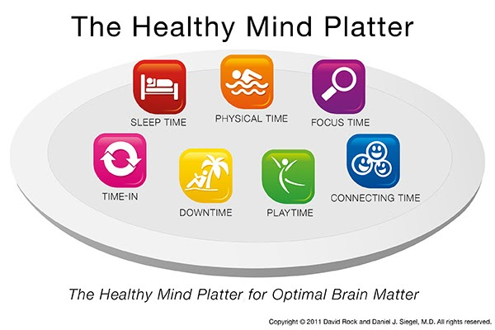
Siegel created “Healthy Mind Platter,” which compares to the Food Pyramid or MyPlate, but for mental health. Take a look:

Here is a quick overview created by Siegel:

Focus Time: When we closely focus on tasks in a goal-oriented way, we take on challenges that make deep connections in the brain.

Playtime: When we allow ourselves to be spontaneous or creative, playfully enjoying novel experiences, we help make new connections in the brain.

Connecting Time: When we connect with other people, ideally in person, and when we take time to appreciate our connection to the natural world around us, we activate and reinforce the brain's relational circuitry.

Physical Time: When we move our bodies, aerobically if medically possible, we strengthen the brain in many ways.

Time In: When we quietly reflect internally, focusing on sensations, images, feelings, and thoughts, we help to better integrate the brain.

Downtime: When we are non-focused, without any specific goal, and let our mind wander or simply relax, we help the brain recharge.

Sleep Time: When we give the brain the rest it needs, we consolidate learning and recover from the experiences of the day.

One portion to highlight is "time in." This practice asks us to reflect and focus on the present. Bringing awareness to our thoughts and emotions can be as simple as taking a few minutes to focus on our breathing patterns or being aware of the trees or birds while on a walk. It is my hope your holiday holds many of these moments.

I encourage you to review this platter and take inventory. Be aware of any feelings of guilt or shame creeping in during this process. It is okay if portions of your platter are missing in this season, but it is possible to add small practices even now. We need to protect our own (and children's) mental health and wellbeing more than ever. If your family or child is experiencing significant barriers to incorporating these practices or your child is displaying ongoing emotional or behavioral difficulties during this time, please feel free to reach out to a member of the counseling team.

Happy Holidays to you and yours. May these two weeks be filled with unexpected rest, joy, and connection.

Lindsey Shafto,
MSW, LSWAIC

Need Assistance? Can you Help?

Do you or someone you know connected to CPMS need assistance? CPMS has financial assistance available to help CPMS families through difficult times. If you think a family may need assistance or maybe you are just unsure, please send Eileen Jowell an email. Although we will pause email and other communication during break since our school is closed, we will respond to requests when we return from break.

Wondering how you can help? See below.
- Donation Option 1: Send a check to Northshore School Foundation! Donors need to identify the donation is for "CPMS Opportunity Fund". Mail to NSF at 13110 NE 177th Place B101-103, Woodinville, WA 98072
- Donation Option 2: On-line donations to Northshore Schools Foundation. Select the "Removing Barriers" option from the drop-down menu AND Donors need to email Heather@nsdfoundation.org to identify the donation is for "CPMS Opportunity Fund".
Community Resources shared with families in the recent newsletter can be found on our CPMS webpage. Thank you for keeping CPMS strong! ~ Eileen Jowell, Dean of Students

Second Semester distribution day

Mark your calendars: Wednesday, February 3rd from 8-11 am and 1-4:30 pm.
Due to am distribution, office hours with staff may be impacted on that date. This is one of BHS’s distribution date as well and we believe it will be beneficial for families to have one coordinated pick up date. More details will be shared in upcoming communications.

Washington Listens provides free support

Are you feeling the stress and anxiety of COVID? Sometimes it hits you hard and you need someone to listen? There is a new resource for support that has a real person to talk to! Washington Listens https://www.walistens.org/ is a new program that provides nonclinical support to people experiencing elevated stress due to COVID-19. Call 1-833-681-0211 to be connected to a live support specialist. The support specialist will listen. The program is anonymous and no identifying information is maintained. 9am-9pm M-F, and 9am-6pm weekends.

winter break numerade courses

This Winter break Numerade is offering several virtual "Bootcamp" courses in specific subjects to students at no cost. Each of these courses are taught by experts and college professors and are designed to keep students engaged with their studies over break. These are offered at zero-core to ensure students have equitable access to STEM education everywhere. Please enjoy this opportunity for learning during winter break.
SAT Prep📝  Pre-Calc 🤓  Calc AB AP 🧮  Chemistry AP ⚗️ | Calc BC AP 📉  Physics AP ⚙️  Bio AP🧬 | Algebra 1 ➕  Algebra 2 ➗  Geometry 🔺  Physics 102 🔥 | Chem 102 🧪  Calc 103 📈  Physics 103 ⚛️
https://www.numerade.com/bootcamps/

thank you art students and ms. christensen!

Please enjoy these fabric art pieces from our students- so creative!

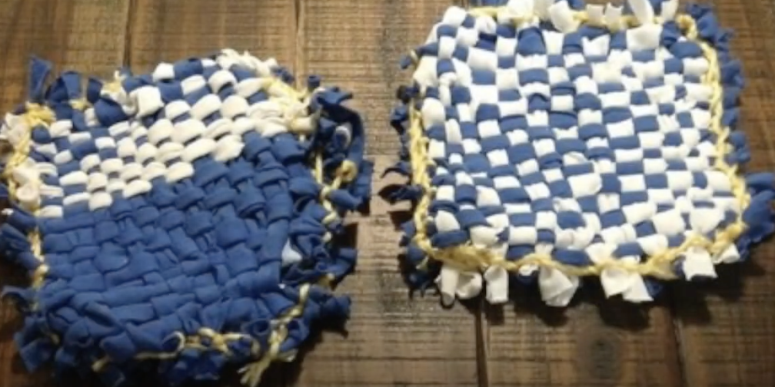 | 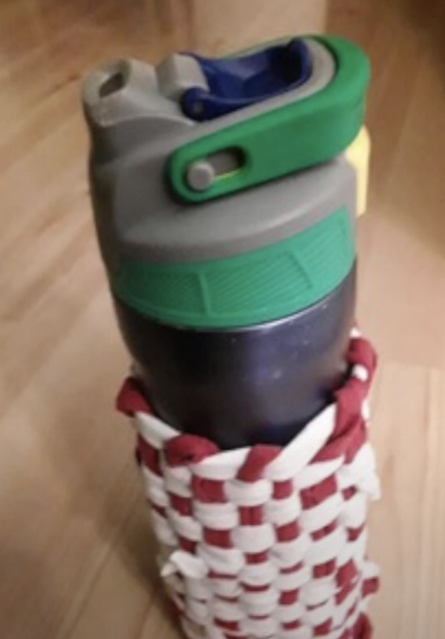 | 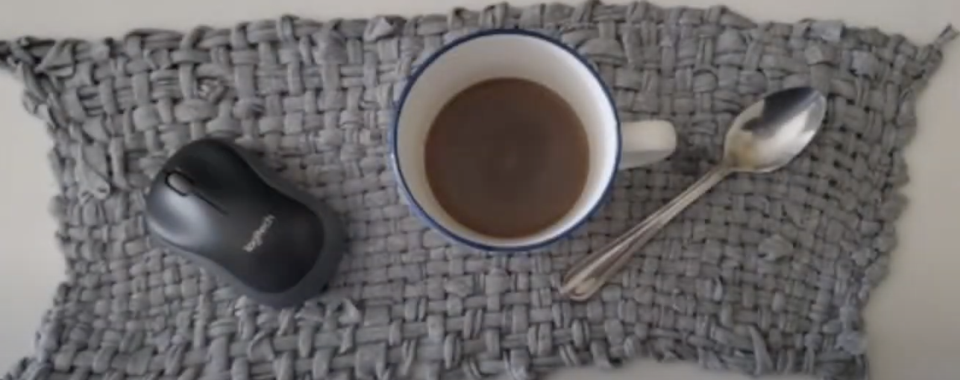

counseling connections

Tips for Coping During Coronavirus as we head into winter and winter break
· Parents, you matter! This article explains how important it is for parents/guardians to take care of themselves as much as possible:
https://childmind.org/article/self-care-in-the-time-of-coronavirus/
· Tips for Supporting your Teen/Tween: https://childmind.org/article/supporting-teenagers-and-young-adults-during-the-coronavirus-crisis/

Things to do at home during winter break

- Load up a cup of cocoa with whipped cream or marshmallows
- Take a wintry hike
- Build a gingerbread house
- Cut paper snowflakes
- Make a birdfeeder out of pinecones, peanut butter, and birdseed—and place it near your window for a show

- Bake cookies to share with your friends and neighbors
- Drop off flowers on someone’s porch
- Build a pillow fort
- Enjoy a living room picnic
- Host a movie marathon of all your favorites
- Eat dinner by candlelight
- Plan a virtual game night

We wish you all a wonderful holiday break! If you or someone you know needs immediate support outside of school hours, please contact one of the following:

*Call Teen Link: 206-461-4922, 6:00-10:00 pm nightly, staffed by teens
*Text Teen Link: 866-833-6546, 6pm-9:30pm
*24-hour Crisis Line: 1-866-427-4747, to speak with an adult crisis expert
*National suicide prevention crisis line: 1-800-273-TALK (8255)
*Dial 911 if you have an emergency and need help

Contact Information

MAIN OFFICE TEAM:

Myra Arnone, Principal – marnone@nsd.org 425.408.6305
Dave Watson, Assistant Principal – dwatson2@nsd.org 425.408.6325
Eileen Jowell, Dean – ejowell@nsd.org 425.408-6324
Kim Swanson, Office Manager – kswanson@nsd.org 425.408.6301
Jill Mildenhall, Registrar – jmildenhall@nsd.org 425.408.6318
Debbie Fisher, ASB – dfisher@nsd.org 425.408.6303
Colette Puoci, Attendance – CPMSattendance@nsd.org 425.408.6310.
Nick Griego, STS ngriego@nsd.org 425.408.6362

COUNSELORS:
Julie Brock, Counselor (Last name A-G) - jbrock@nsd.org 425.408.6365
Lizzy Ward, Counselor (Last Name A-G) - eward@nsd.org 425.408.6320
Paul Narancic, Counselor (Last Name O-Z) - pnarancic@nsd.org 425.408.6321
Elizabeth Methot, Counselor (Last Name H-N) - emethot@nsd.org 425.408.6313

CANYON PARK PTSA

As we say good riddance to 2020 we want to thank all the parents and guardians that continue to do the hard work of supporting your students. Use this time over break to connect with them about what has worked and what could be better and encourage them to clean up their learning space and get re-organized. And, to the teachers and staff at Canyon Park Middle School, please put your feet up during winter break, you deserve it!

We will soon be sending out a “State of the PTSA” Newsletter via a MailChimp email. This newsletter will be full of updates on what your PTSA has been up to these past few months as well as a look at things to come. To be sure it lands in your inbox and not junk folder, add communication@cpptsa.org to your contacts. It will also be posted to our website cpptsa.org/newsletters in case you are not on our email list. Please take a few minutes over winter break to review it.

Let’s all believe that good things will be coming in 2021 -- we can make it happen. As Dr. Reid always says, “Imagine the possibilities....”

