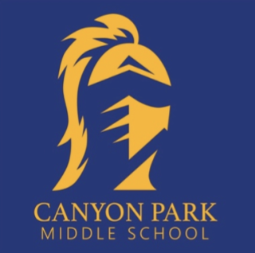
CANYON PARK NEWS
Home of the Knights
August 8, 2021 Vol. 01

Welcome Back Canyon Park
Bell Schedule(s)
School Picture Day
WEB Leader Training Dates
WEB Day for 6th Graders – Sept. 1st
Community Serve Day – Aug. 22nd

NSD Back to School Fair
Middle School Sports
Clubs
Lockers
Miscellaneous School Fees
Free Meals for All Students
Contact Information

Welcome back canyon Park

We are so excited for the return to school this year - every year brings new opportunities to build our relationships, make new friends, and engage with our school and community! I am especially excited to come back to a school year where we greet our students in-person and “at the door.”

Our mission at Canyon Park is to provide our students with a challenging, equitable, empowering, and developmentally responsive education. We continue our commitment to delivering this caliber of education through the lens of racial and educational justice, equity, access, and opportunity. We know that our relationships with our students, staff, families, and community are instrumental in these efforts, and one of our goals this year is to continue forming strong partnerships and alliances with those whom we serve.

To this end, our school’s theme this year is:

BELONGING THROUGH DIGNITY

This year, all of our buildings will effectively be launching “new” schools. We have an opportunity to do foundational orientation work. Our school will focus on building relationships that are rooted in belonging and on creating inclusive, welcoming spaces that will address the challenges created and/or amplified by the pandemic.
We start this focus on BELONGING the first day of school- Wednesday, September 1, 2021. On this day, we plan to greet incoming 6th graders for Where Everybody Belongs (WEB) Day.
Our 6th grade students will have a chance to engage with their peers, our staff, and school before they start their classes. ALL 6th, 7th and 8th Grade students will attend school on Thursday, September 2, 2021.

I also wanted to share a few important updates:

Bell Schedule/Drop Offs/Transportation
- Our bell schedule has changed- school begins at 7:55 and ends at 2:30pm except for Early Release Wednesdays when school will be dismissed at 1:00pm. Please see new bell schedule below
- We will be on a 6-period schedule for the 2021-22 school year
- Due to supervision requirements, students must arrive after 7:30 am
- District transportation will be communicating bus schedules to families later in August

Class Requests
Our school considers all student requests made the previous year when we balance our classes, hire staff, and build in intentional student support throughout the day. Due to these efforts, student schedule changes will only be considered by our counseling team if there are errors or “empty” periods. Students’ schedules will be released online on August 24, 2021.

School Supplies
We are in the process of shifting all students to 1:1, where each student will be provided with a tech device for academic use. More information to come on school supplies needed. We do know that students will be expected to wear masks on campus this year. More information to come regarding Covid as we continue to adapt to COVID-related guidance from our District and state.

Looking forward to a strong and positive start to our school year!

Myra Arnone
Principal, Canyon Park Middle School 425-408-6305

Bell Schedule

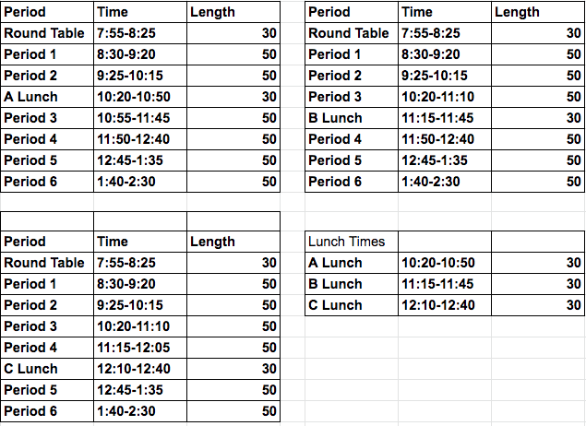

Early release Wednesday Bell Schedule

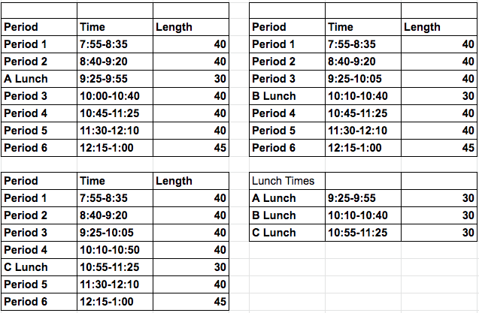

School Picture DaY

Students will have an opportunity to get their school pictures taken and receive their ID cards.

An email will be sent soon with the following:
- Link to sign up for a time that works for you via Sign-Up Genius
- Digital picture order form. Paper copies will be available on-site for students on August 18th

This event will be for school pictures only (parents and siblings will not be allowed to get out of their vehicle) For those who cannot make it on this day, there will be a make-up day on September 9th during school.
If you have questions regarding school pictures, please contact Debbi Fisher at dfisher@nsd.org.

WEB LEADER TRAINING DATES

WEB Leaders! We are excited to announce that we have our training dates! While we are still waiting on specifics from the district to determine the time our trainings will take place on these dates, please add Monday, August 23rd and Wednesday, August 25th to your calendar!

Please bring your enthusiasm for WEB, a face mask, and wear comfortable shoes, as our training includes lots of movement and you will want to be comfortable. More information to come about the times for the two training days. We are looking forward to seeing you at the WEB training. Thank you for being a WEB leader!

WEB DAY for 6th Graders – September 1st

Each year on the first day of school, we hold WEB Day, which is a fun-filled orientation designed to welcome, transition, and support all sixth graders by assigning them two eighth grade WEB Leaders as mentors, not only for the day, but throughout the school year!

WEB: 6th graders! We have saved the first day for you. The day will be all 6th graders and our WEB leaders. There will be transportation for the 6th graders and WEB leaders. Our WEB leaders are excited to meet you and help you navigate Canyon Park to give you the best first day of school. 7th graders and 8th graders that are not WEB leaders, you have an extra day to organize your school supplies 🙂.

Community SERVE DAY - August 22nd

NSD Community Serve Day will be on August 22nd from 9-1:00pm. Join families and community members to help ready schools for the start of the 2021 - 2022 school year! Volunteers are needed to help improve the campus through painting, weeding and more!

NSD BACK TO school FAIR

August 28th - 10:00 AM - 2:00pm Pop Keeney Stadium, 9809 NE 188th St, Bothell, WA 98011, USA
More information: https://www.nsd.org/back-to-school-fair

MIdDle School Sports

We are awaiting guidance from the state and school district regarding middle school sports. In the meantime, families are welcome to register and submit sports physicals for first season sports on Finalforms. We will not be receiving payments until middle school sports have been confirmed. If you have questions regarding sports, please contact Debbi Fisher at dfisher@nsd.org.

CLUBS

Canyon Park has a variety of clubs. Please see our website for clubs that have been available in previous school years. There will be more information regarding clubs for the 2021-22 school year in September. Information regarding clubs will be communicated via Schoology.

Lockers

School lockers will not be assigned to students. If, after the first few weeks of school, your student is finding a locker may be useful, please have them fill out a locker request form in Ms. Fisher’s office, starting on September 13th.

Miscellaneous School Fees

We will not be accepting any fees at this time for the following: Yearbooks, ASB Cards, sports, clubs etc.

Free MEALS FOR all students

For the 2021-22 school year, Northshore School District will offer breakfast and lunch each school day at no charge to all students. Milk is included with breakfast and lunch or can be purchased separately. The cost of meals is subject to change annually.

Contact information

MAIN OFFICE TEAM:
Myra Arnone, Principal – marnone@nsd.org 425.408.6305
Dave Watson, AP – dwatson2@nsd.org 425.408.6325
Eileen Jowell, Dean – ejowell@nsd.org 425.408-6324
Kim Swanson, OM – kswanson@nsd.org 425.408.6301
Jill Mildenhall, Registrar – jmildenhall@nsd.org 425.408.6318
Debbie Fisher, ASB – dfisher@nsd.org 425.408.6303
Colette Puoci, Attendance – CPMSattendance@nsd.org 425.408.6310
Nick Griego, STS ngriego@nsd.org 425.408.6362
COUNSELORS:
Julie Brock, Counselor (Last name A-G) - jbrock@nsd.org 425.408.6365
Lizzy Ward, Counselor (Last Name A-G) - eward@nsd.org 425.408.6320
Paul Narancic, Counselor (Last Name O-Z) - pnarancic@nsd.org 425.408.6321
Elizabeth Methot, Counselor (Last Name H-N) - emethot@nsd.org 425.408.6313

