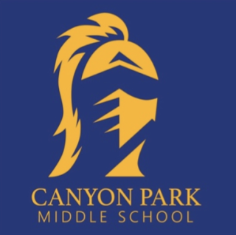
CANYON PARK NEWS
Home of the Knights
January 29, 2021 Vol. 21

Black Lives Matter
National School Counseling Week
Students Share Your Voice
Spirit Wear Store Closes Sunday
Counseling Connections
S2 Distribution Day – Wednesday

Yearbook Pre-Sales Going On Now
Library Book Pick Up
Contact Information
PTSA
Music Boosters

Black Lives matter at school – Week of action 2/1-2/5

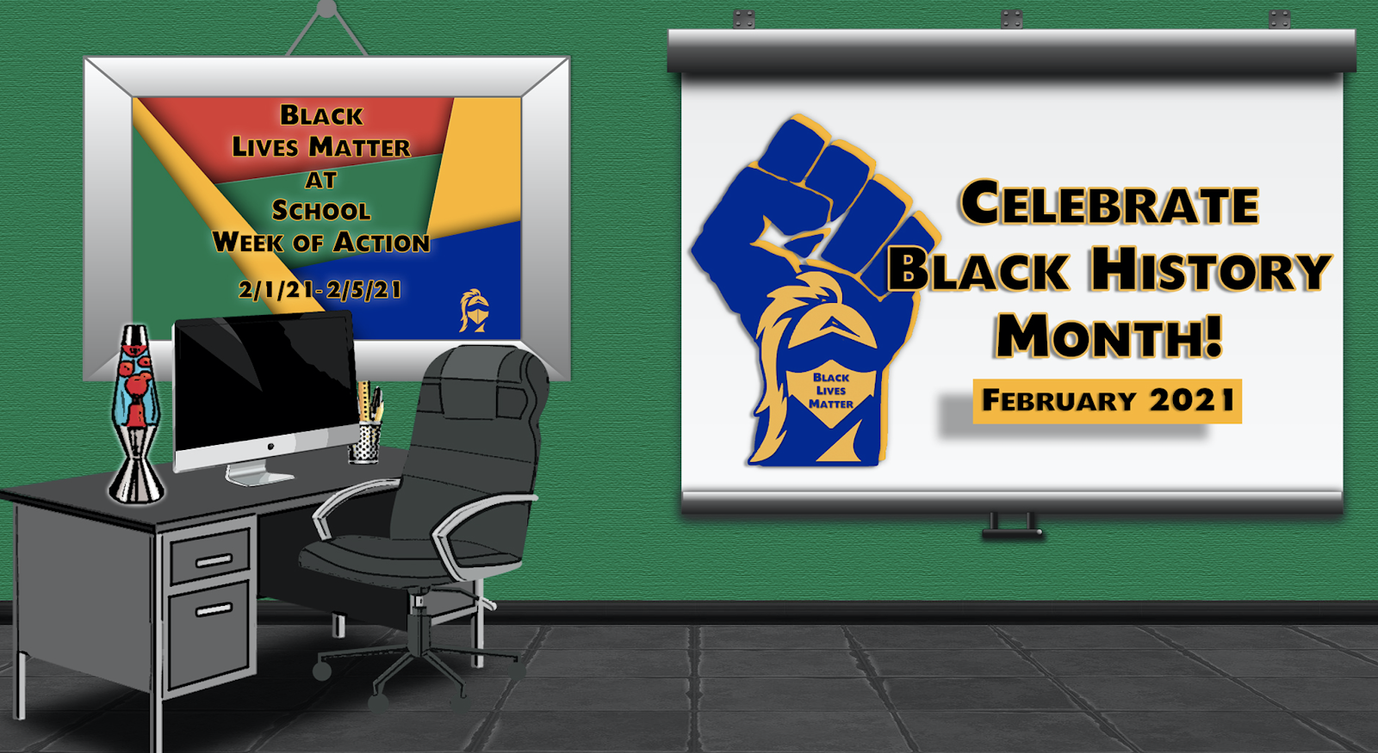
A Next week, Canyon Park staff and students are eager to celebrate, affirm, and show solidarity toward Black/African American people in partnership with our District’s Black Lives Matter at School - Week of Action, a nationwide movement to assert the status of Black lives in our society as equal to, and never secondary, the lives of other peoples.

Our Canyon Park students will be featured in several of the week’s events, most notably a panel discussion facilitated by our District’s Racial and Educational Justice team.
Canyon Park is committed to its focus on racial and educational justice for all students, families, and staff, and will continue to encourage a diverse, inclusive, educational environment through the celebration of Black History Month throughout the month of February.

In preparation for this month, a big thank you goes out to our Racial and Educational Staff Team and Student Club!

Please see a schedule of events in this Newsletter and check out our District’s BLM page and Board Resolution No. 818 - https://www.nsd.org/our-district/who-we-are/racial-educational-justice/blm

-Myra Arnone
Principal, Canyon Park Middle School

National school counseling week

At Canyon Park we know the contributions and impacts that our counseling team makes on a daily basis and towards the long-term goals of setting up successful outcomes for students in school, their careers, and their lives. Counselors are certificated educators that address our student’s socio-emotional, academic, and future career needs, and towards these ends, work directly with families, staff, and other professionals in the District and community.

Our CPMS Counseling Team is supportive of all of our students and have shown courage and empathy- especially in light of the hardships our students, families, and staff have faced this year.

Join me in celebrating our CPMS Counseling Team: Elizabeth Ward, Julie Brock, Paul Narancic, and Elizabeth Methot!

We welcome student and family emails of appreciation - feel free to send them directly to the counselor or counseling team.

Students share your voice

The Northshore School District Communications Department has a number of ways that students can share their music and arts talent with the community during an upcoming virtual event.

We are seeking students to share their voice through spoken word poetry at our fourth annual State of Our Schools. The virtual event, which will be held in March for leaders within our community and District, will share our successes from the past year, provide exciting updates on new buildings, and share some of the innovation and inspiration taking place throughout Northshore. Including student voice is essential and to that end we invite students to submit spoken word poetry that expresses how the District inspires them and prepares them to turn the page to their next chapter as a student or life beyond Northshore. Submissions are being accepted through Friday, Feb. 12, 2021 from all Northshore students who are interested in performing for the State of Our Schools virtual event.

A small number of student musicians are also needed for the event to pre-record a performance to be played during the event. If you are a student or student group familiar with playing a set that is classical, jazz or easy listening and you are interested in performing for State of Our Schools, please complete a submission form. These entries will be accepted through Friday, Feb. 12, 2021.

Spirit Wear – Store closes Sunday

Canyon Park Middle School Spirit wear closes this Sunday 1/31/21 so order this weekend!

Click link https://www.companycasuals.com/cpms

Counseling Connections

We made it halfway through the year! We hope you take some time to recognize your student for all the hard work they put into first semester and all they have accomplished so far (and remember to recognize all that YOU have accomplished too!). First semester was challenging and for many of us, the longer we work remotely, the harder it seems to maintain motivation. But remember, we can do hard things! When it feels tough, here is a “Pick One” exercise you can use to help strengthen your resiliency skills in three ways: through building stability, positive mindset, and daily life satisfaction:

Pick ONE routine that was normal before and incorporate it into your life again. When we went to school and work in person, our days were much more structured with routines. While these routines may no longer be necessary, they can help ground us in our daily lives.
Here are some ideas:
- Getting dressed in clothes you would normally wear to school (not pajamas/sweats)
- Taking a shower
- Fixing your hair
- Eating breakfast before school starts
- Doing some physical activity right after school ends

Pick ONE thing that's positive even in challenging circumstances. We’ve focused on gratitude and healthy mindset a lot this year because they have such an immense impact on our mood. Some families choose to share one thing at the dinner table each night that they are grateful for, even during hard times. Here are some ideas:
- The kindness of others
- Sunny days
- Longer periods of daylight
- Daffodils starting to break through the ground
- Friends and family to talk to

Pick ONE thing to do that is good for you that you have been putting off. Maybe this is a healthy habit you’ve been meaning to start or maybe it is just something you want to do differently in your life. This does not have to be something big, even small actions can have huge impacts and can provide a sense of accomplishment. Here are some ideas:
- Going for a walk
- Sending a message to someone you haven't talked to in a while
- Making a healthy meal
- Setting the table
- Making your bed
- Going outside for at least 30 minutes
- Eating together at the dinner table
- Completing your homework at a specific time
- Turning off technology for a few hours a day

Second Semester (S2) Distribution DAY – Wednesday Feb. 3rd
Wednesday, February 3rd from 9-11 am and 1-4:30 pm.
Please come during the time scheduled below (Last Name):
9:00 - 10:00 am: A-C
10:00 - 11:00 am: D-H
Break: 11:00 am - 1:00 pm (Pick-Ups Not Available)
1:00 - 2:00 pm: I-L
2:00 - 3:00 pm: M-P
3:00 - 4:00 pm: Q-U
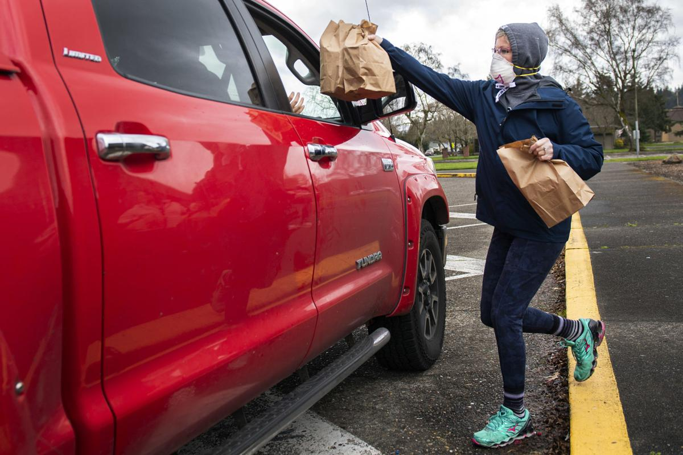
4:00 - 4:30 pm: V-Z
· Prepare a sign with your student(s) last name,
first name and grade
· Display this sign within the windshield of your driver side dashboard so that it is clearly visible
· You may only pick up items that belong to your student
· For safety purposes, all parents/students/passengers must
stay in the car at all times
· Please wear a mask

YearBook Pre-Sales Going on NOw!

Final Opportunity to pre-purchase the 2020-21 Canyon Park YEARBOOK starts February 1^{sth} and will go through February 24th. After that, yearbooks will only be available for purchase while supplies last (when yearbooks are distributed).

The price for the yearbook is $20.00 for all students. Please contact your student's counselor if they would like a yearbook and there is a financial need.

Online sales are highly encouraged. Please go to https://wa-northshore.intouchreceipting.com/ to order a yearbook. Please contact Debbi Fisher at dfisher@nsd.org if you need your TouchBase username and password.

If you cannot purchase online, please make a check out to CPMS and send to (please note student's name in the memo line):

Canyon Park MS
23723 23rdAve SE
Bothell, WA 98021
Attn: Debbi Fisher

library book pick up

When: Every Wednesday from 11AM-2PM
Where: Canyon Park Main Office – look for the yellow sign

How: Students need to go to the library catalog and place a hold on the title(s) they’d like and then complete the curbside pick-up form. An instructional video is linked under the “2020-2021 Live from the Library” section of my webpage and it was shown in all English classes. You will find the curbside pick-up form in the corresponding section on that same webpage. As long as you make your requests by 8AM Wednesday mornings, you can assume your books will be ready the same day!

In addition to curbside pickup at Canyon Park on Wednesday, library books will be delivered to four locations in the Canyon Park area on Thursdays.

Where will the books be delivered?
If you live near Canyon Park, you can pick up your books near the main entrance on Wednesday between 11a.m. and 2 p.m. On Thursdays, books will be delivered to a bus stop or lunch pickup location near you. An NSD bus driver, with an NSD staff member, will deliver books using the schedule below:
 | Stop Location | Time
School Canyon Park MS | NE 195th & 100th AVE NE | 11:50
Day of the week Thursday | Bothell HS (Bus Load Zone) | 12:15
 | Meridian Ave S. @ 233rd Pl SE | 12:30
 | Crystal Springs (Bus Load Zone) | 12:50

Please arrive on time. The bus will only stay for a short amount of time before departing for the next stop. We require that all families wear a mask and maintain physical distance when picking up their books. Bus drivers and helpers will also wear masks. The books will be distributed in a plastic bag labeled with the student’s name. Books will be checked out for three weeks. If you need the book renewed, or have questions please contact Mrs. Dodson – ndodson@nsd.org

How will the library know I want to check out books? Complete the Book Request Form.
There will be a 3-book limit, so if you are picking up new books from the bus, be prepared to return your previous books.

Contact Information

MAIN OFFICE TEAM:

Myra Arnone, Principal – marnone@nsd.org 425.408.6305
Dave Watson, AP – dwatson2@nsd.org 425.408.6325
Eileen Jowell, Dean – ejowell@nsd.org 425.408-6324
Kim Swanson, OM – kswanson@nsd.org 425.408.6301
Jill Mildenhall, Registrar – jmildenhall@nsd.org 425.408.6318
Debbie Fisher, ASB – dfisher@nsd.org 425.408.6303
Colette Puoci, Attendance – CPMSattendance@nsd.org 425.408.6310
Nick Griego, STS ngriego@nsd.org 425.408.6362
COUNSELORS:
Julie Brock, Counselor (Last name A-G) - jbrock@nsd.org 425.408.6365
Lizzy Ward, Counselor (Last Name A-G) - eward@nsd.org 425.408.6320
Paul Narancic, Counselor (Last Name O-Z) - pnarancic@nsd.org 425.408.6321
Elizabeth Methot, Counselor (Last Name H-N) - emethot@nsd.org 425.408.6313

CANYON PARK PTSA
Last Chance!! Every membership purchased for the 2020-2021 school year through midnight, February 2nd, will be entered to win an ICE CREAM PARTY BASKET! https://cpptsa.org/membership/ The basket will include a few custom-made quarts of ice cream (classic or alternative milk - you choose!) as well as toppings and sauces...all home-made by a CPMS parent who is hoping to open an ice cream shop in Bothell!

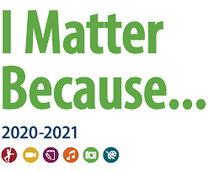
Congratulations to all of the CPMS artists who moved on to the Council level of judging for the 2020 Reflections Art Competition! The judging results are in! A very special congratulations to the following artists: Lacie M. - Judge’s Choice, Cassandra R. - State Qualifier, & Chloe C. - State Qualifier. GO KNIGHTS!

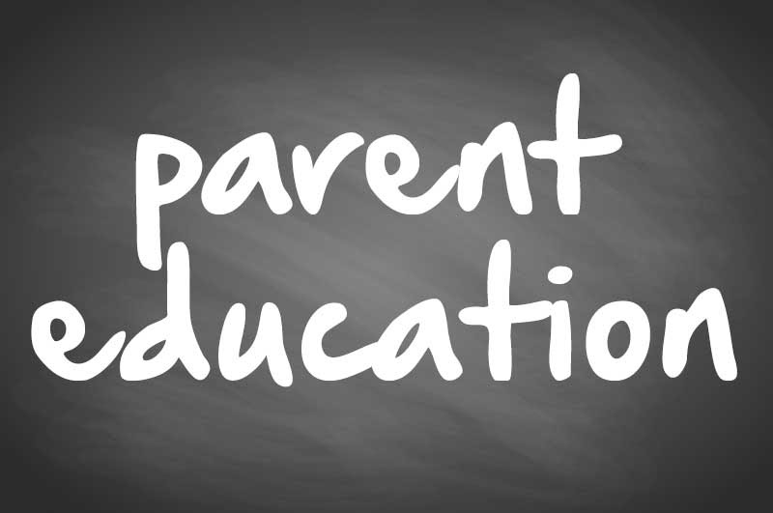
Parenting Education and Coaching Program with Cher Anderton
REGISTER HERE Coupon code: CANYONMS
This Parenting Education and Coaching Program includes six modules of online content as well as twice monthly live sessions (one mid-day, one evening). The online content is called “Anchored Families: 5 Must Have Tools in your Parenting Toolbox.” The live sessions allow you and other parents/caregivers to raise questions and share ideas with Cher Anderton, a mental health therapist.
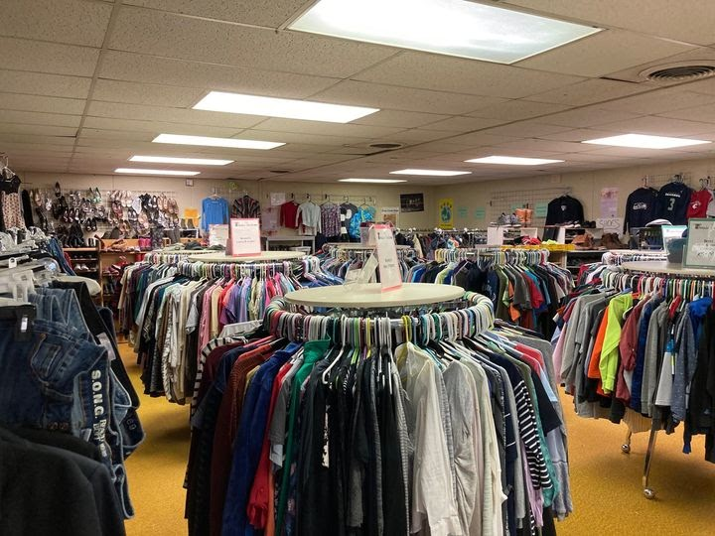
Threads and Treads is in need of donations - especially warmer coats for the whole family. Donations can be dropped off at T&T on Wednesdays from 2:30-6pm. We are also in need of new underwear in all sizes. If you’d like to donate, please check out our Amazon.com Wish List! Thank you for your continued support of this program and our families!

CPMS PTSA Meeting
Wednesday, February 10th @ 7PM on Zoom (check next week’s newsletter for Zoom link). All are invited to attend! You do not have to be a PTSA member to join us in this conversation of all things Canyon Park!

CANYON PARK Boosters Music Notes

NSD HONOR BAND & ORCHESTRA
Congratulations to the 23 music students who qualified for NSD Honor Band and Orchestra!
BAND: Addie Whitehill, Ramona Ortiz-Wilson, Julia Watts, Ramola Rajkumar, Lucas Wong, Patrick Monahan, Chase Bachmeier, Kairui Cheng, Krish Uppalli, Matthew McAllister, Andrew Bush, Toki Young, Megan Luke, Ian Blakemore, Aiden Standridge, Derek Sabale, Thomas Holmes, Halsey Rubenstein, Trevor Wang
ORCHESTRA: Franklin Carter, Emma Le Metzger, Sanjana Saran, Priscilla Ye

Rehearsal
- Wednesday 2/3 from 1:00-2:00pm
Performance
- Wednesday, 2/24

NW JR ALL STATE BAND & ORCHESTRA
Congratulations also to our music students who qualified for NW Jr All State Band! Students from across Washington state submitted auditions, and selected students are recognized with acceptance into these state-wide ensembles. You can be very proud of your accomplishment and of your hard work during this challenging year!

Ian Blakemore - Trombone
Kairui Cheng - Alto Saxophone
Soraya Fulcher - Clarinet
Emma Le Metzger - Violin
Patrick Monahan - Clarinet
Halsey Rubenstein - Percussion
Krish Uppalli - Alto Saxophone
Addie Whitehill - Flute
Lucas Wong - Clarinet

