Canyon Park Middle School Staff Newsletter - 03/19/21 Volume 27

CPMS Message In Solidarity With Our Asian Communities:

We sent this message to our community earlier this week and in today’s Family Newsletter. We share it again with you:

The Canyon Park staff, alongside the Northshore School District, would like to extend support to our Asian families who are/have experienced some form of discrimination and or oppression. To our Asian families, hand in hand, we stand against those who have taken the opportunity to victimize and openly practice abuse towards individuals whose culture and customs we accept and celebrate.

In partnership with our Asian students, families, and communities,
Canyon Park Middle School Staff
Anti-Asian Racism and Hate Reporting and Resources
CPMS and NSD are committed to a safe and civil educational environment for all students, employees, parents, guardians, volunteers and patrons that is free from harassment, intimidation and bullying. It strives to provide students with optimal conditions for learning by maintaining a school environment where everyone is treated with respect and no one is physically or emotionally harmed.
Staff- please review our Harassment, Intimidation and Bullying website that includes resources regarding Anti-Asian Racism and Hate Activity Reporting & Resources
Here is the HIB Reporting Form for ANY reporter:
https://resources.finalsite.net/images/v1524223836/nsdorg/bgeixugxhg5adivyt6nt/HIBIncidentReportingForm.pdf

Principal's Day Agenda - Wednesday, 3/24/2021 - 1:35 - 3:05 pm
- Overview/Key Points of Guiding Documents (TBD from guidance forthcoming)
- COVID-Hybrid Planning Team updates
- Departmental brainstorms
- Whole group debrief
We ask for your flexibility and participation- we will keep it informed, positive, collaborative, and we will work on this TOGETHER!

COVID Hybrid Planning Team

Great news! Staff members are very interested in joining the COVID Hybrid Planning Team.
At this point, we are talking about COVID logistics of bringing students into campus, communication, safety, and future planning. We are waiting on more information from District to be released regarding "Hybrid" portion - master and bell schedules, classes, classrooms, lunches, etc.
You are welcome to join us even if you have 1st period as we begin these conversations at 7:30 am.
Please feel free to remain until you need to jump off to class. If you are interested in joining, please inform Myra or Kim.

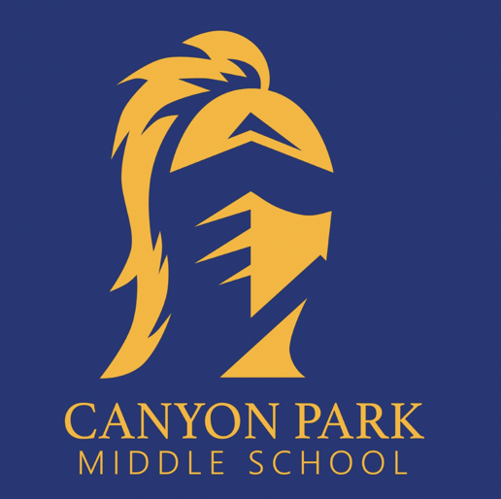 | Myra Arnone | Principal  a: Canyon Park Middle School | 23723 23rd Ave SE | Bothell, WA 98021  e: marnone@nsd.org | w: www.canyonpark.nsd.org  p: 425-408-6305
Bookings: Click this link to book with me!
Zoom room: https://nsd.zoom.us/my/myraarnone
"Find a way to get in trouble, good trouble, necessary trouble. Be prepared to speak up and speak out, be courageous. When you see something that’s not right, not fair, not just, you have a moral obligation to get in the way and make some noise." - John Lewis, Civil Rights leader

Confidentiality Notice: This message, including attached files, may contain confidential information and is intended for a specific recipient. If you are not the intended recipient, please notify the sender immediately and delete the message.
CANYON PARK NEWS
Home of the Knights
March 19, 2021 Vol. 28

Canyon Park Families
Anti-Asian Racism and Hate Reporting
A Note from Our Mental Health Therapist
After School On-line Programs
2021-22 School Year Calendar

Student Voice Opportunity - 8th Graders
Counseling Connections
Library Book Pick-Ups
Contact Information
PTSA

Canyon Park Families

The Canyon Park staff, alongside the Northshore School District, would like to extend support to our Asian families who are/have experienced some form of discrimination and or oppression. To our Asian families, hand in hand, we stand against those who have taken the opportunity to victimize and openly practice abuse towards individuals whose culture and customs we accept and celebrate.

In partnership with our Asian students, families, and communities,

Canyon Park Middle School Staff

Anti-asian racism and hate reporting and resources

CPMS and NSD are committed to a safe and civil educational environment for all students, employees, parents, guardians, volunteers and patrons that is free from harassment, intimidation and bullying. It strives to provide students with optimal conditions for learning by maintaining a school environment where everyone is treated with respect and no one is physically or emotionally harmed.

Please review our Harassment, Intimidation and Bullying website that includes resources regarding Anti-Asian Racism and Hate Activity Reporting & Resources

A note from our mental health therapist

The strain and uncertainty surrounding COVID-19 and remote learning continues to elevate the topic of mental health to the forefront of parents, educators, students, and community members' minds. Many families are looking for ways to support their child’s mental health as they continue to face transitions and losses related to the pandemic.

As the mental health therapist at Canyon Park, I get the incredible opportunity of supporting students' mental health during this difficult time. I am so proud of the students' resiliency and adaptability this year. Yet, I realize many students find themselves needing additional support as they face unwanted and unmanageable emotions and situations.

Canyon Park will be offering a self-assessment wellness screener to students called “Check Yourself”. This interactive teen-friendly survey asks questions around four main areas: Strengths (goals, supportive relationships, and school connectedness); Substance use (potential to use, use in the past year, and frequency of use); Mental Health (anxiety, depression, PTSD symptoms, and self-harm thoughts) and Safety (harassment, feeling safe at school, and context at home). For school support teams, this tool will help start conversations with students around healthy lifestyle choices, safety, and address any areas of concern or student needs. Parents and guardians will also be notified if their student(s) can benefit from additional support(s) at school or within the community.

English: https://www.youtube.com/watch?v=u6WR4z4g3S4
Español: https://www.youtube.com/watch?v=iNpdv16yDKU

We will provide more information in the coming weeks. Our team cares deeply about each student’s mental health and well-being, and we are looking forward to supporting students in the way they need it most.

After-School Online Enrichment Opportunities

NSD has contracted with 6crickets who continue to maintain a database of community organizations that are offering spring break and after-school enrichment opportunities through the end of the 2020-2021 school year. To view these opportunities please visit the Online Enrichment webpage.

2021-22 School Year Calendar
The 2021-22 school year calendar has been finalized and is available on the District website. Be sure to mark your calendar with important dates. View the calendar.

Student Voice Opportunity – 8th Graders

Student Voice Opportunity for students in grades 8,9,10. Northshore Youth Voice are focus groups that Northshore Schools Foundation organized with the Northshore YMCA. Youth share their thoughts about programs aimed at serving them, plus, participants earn community service hours.

At the upcoming session on Tuesday, March 23rd, students will talk about staying connected through hobbies and shared interests. This has been especially hard at this time when we can’t be together. We’ll ask kids in grades 8, 9, and 10 to share experiences and expertise about things students can and want to be doing together. Input will be shared with local nonprofits and community-minded organizations who want to see if they can safely coordinate or host activities for students to participate in together.

A limited number of spots are still available for the March 23rd group. Interested students in grades 8, 9, and 10 can register at https://nyshobbies.eventbrite.com. This event is sponsored by The Northshore Schools Foundation.

Counseling Connections

This week we are celebrating longer stretches of daylight, the blooming crocuses and daffodils, and the official arrival of spring this weekend! We want to give a huge shout out to our PTSA and all of our families, staff, and community members who helped make the first ever online Career Day a success. We hope your student felt inspired by all the career possibilities available to them and excited to continue exploring their interests!

Today is the last day of registration for 6th and 7th graders! Please ensure your student has a completed registration by checking the "Course Requests" section of your ParentVUE account. Students should have 12 rows of requested course sections including A and B sections for year-long classes (Ex. ENG750A and ENG750B) and 3-5 alternates for semester electives. All registration instructions and materials can be found on our CPMS counseling page located here.

Finally, we know that big changes are up ahead and changes--even good ones--can bring up anxiety. We want to acknowledge that in all of our lives there are moments where there can be a need for more support. Living through a worldwide pandemic has at times taxed the mental, physical and emotional reserves of adults and students. NAMI is the National Alliance on Mental Illness. They offer many resources that families might find valuable as we all continue working to return to "normal" life. If you are interested in joining an online parent support group, here is one resource provided by NAMI Washington.

library book pick up

When: Every Wednesday from 11AM-2PM
Where: Canyon Park Main Office – look for the yellow sign

How: Students need to go to the library catalog and place a hold on the title(s) they’d like and then complete the curbside pick-up form. An instructional video is linked under the “2020-2021 Live from the Library” section of my webpage and it was shown in all English classes. You will find the curbside pick-up form in the corresponding section on that same webpage. As long as you make your requests by 8AM Wednesday mornings, you can assume your books will be ready the same day!

In addition to curbside pickup at Canyon Park on Wednesday, library books will be delivered to four locations in the Canyon Park area on Thursdays.

Where will the books be delivered?
If you live near Canyon Park, you can pick up your books near the main entrance on Wednesday between 11a.m. and 2 p.m. On Thursdays, books will be delivered to a bus stop or lunch pickup location near you. An NSD bus driver, with an NSD staff member, will deliver books using the schedule below:

 | Stop Location | Time
School Canyon Park MS | NE 195th & 100th AVE NE | 11:50
Day of the week Thursday | Bothell HS (Bus Load Zone) | 12:15
 | Meridian Ave S. @ 233rd Pl SE | 12:30
 | Crystal Springs (Bus Load Zone) | 12:50

Please arrive on time. The bus will only stay for a short amount of time before departing for the next stop. We require that all families wear a mask and maintain physical distance when picking up their books. The books will be distributed in a plastic bag labeled with the student’s name. Books will be checked out for three weeks. If you need the book renewed, or have questions please contact Mrs. Dodson – ndodson@nsd.org

How will the library know I want to check out books? Complete the Book Request Form.
There will be a 3-book limit, so if you are picking up new books from the bus, be prepared to return your previous books.

Contact Information

MAIN OFFICE TEAM:
Myra Arnone, Principal – marnone@nsd.org 425.408.6305
Dave Watson, AP – dwatson2@nsd.org 425.408.6325
Eileen Jowell, Dean – ejowell@nsd.org 425.408-6324
Kim Swanson, OM – kswanson@nsd.org 425.408.6301
Jill Mildenhall, Registrar – jmildenhall@nsd.org 425.408.6318
Debbie Fisher, ASB – dfisher@nsd.org 425.408.6303
Colette Puoci, Attendance – CPMSattendance@nsd.org 425.408.6310
Nick Griego, STS ngriego@nsd.org 425.408.6362

COUNSELORS:
Julie Brock, Counselor (Last name A-G) - jbrock@nsd.org 425.408.6365
Lizzy Ward, Counselor (Last Name A-G) - eward@nsd.org 425.408.6320
Paul Narancic, Counselor (Last Name O-Z) - pnarancic@nsd.org 425.408.6321
Elizabeth Methot, Counselor (Last Name H-N) - emethot@nsd.org 425.408.6313

CANYON PARK PTSA

NEEDED - VICE PRESIDENT!
In order for our PTSA to remain in good standing we need four elected officers. We are still looking for a volunteer to become our next PTSA Vice President!! YOU ARE THAT VOLUNTEER!!! Here are some of the many reasons to step up to leadership in our PTSA:
- It is a great way to be more involved in your students’ school
- You can meet and create relationships with school administration, staff members and teachers as well as other parents and caregivers.
- You can connect and work with other passionate PTA leaders to advocate for children.
- The work you do DIRECTLY impacts our CPMS community.
Our PTSA represents ALL families and students at our school. Share your voice with us by joining our PTSA as an elected officer and make an impact!!! Use this form to recommend yourself or someone else for nomination or contact communications@cpptsa.org.

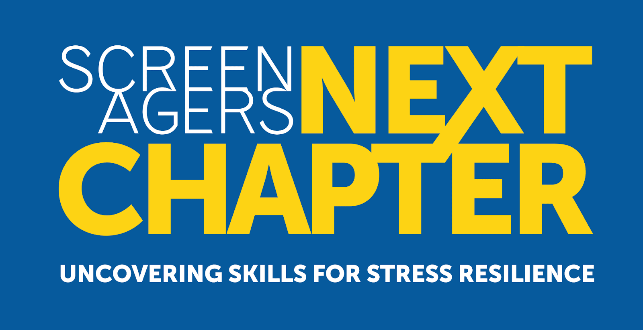
FREE!! SCREENAGERS: NEXT CHAPTER
On-demand virtual movie going on now until March 23rd. Screenagers NEXT CHAPTER: Uncovering Skills for Stress Resilience. Understand the challenges in our current screen-filled society and how we as parents & schools can empower teens to overcome mental health challenges.
Info & Register HERE! Brought to you by Northshore Council PTSA.

Parenting Education & Coaching Program
It’s not too late to sign up! REGISTER HERE Coupon code: CANYONMS. Online content as well as twice monthly live sessions (mid-day & evening) lasting through May that allow you and other caregivers to raise questions and share ideas with mental health therapist, Cher Anderton. “Anchored Families: 5 Must Have Tools in your Parenting Toolbox”

THREADS & TREADS Spring-Time
Threads & Treads is in need of spring-time clothing and socks & underwear for all makes and sizes. Amazon Wish List available! They can be sent directly to the T&T coordinator. Donations can also be dropped off at T&T on Wednesdays from 2:30-6pm or you can email tandt@cpptsa.org to coordinate a drop-off. Thank you!!!!

