CANYON PARK NEWS
Home of the Knights
June 4, 2021 Vol. 36

CPMS Celebrates Pride Month
District-Issued Device Collection Days
Medication Pick Up
Final Yearbook Sales
Counseling Connections

Free and Reduced Meals
Unleash The Brilliance Workshop
Contact Information
PTSA

CPMS celebrates pride month

June 1st marks the beginning of Pride Month, an annual celebration and continued activism in pursuit of LGBTQIA2S+ rights. During this month, shop windows, social media, and pretty much everywhere else are brimming with the rainbow flag, a widely accepted symbol for Pride Month. The rainbow flag, born out of a desire for the LGBTQIA2S+ community to proclaim its visibility and celebrate diversity, is now an international symbol recognized worldwide.

Pride Month is a good reminder that we all deserve to be treated fairly and that we should always stand up for what is right. Canyon Park stands in allyship with the LGBTQIA2S+ community.

~CPMS Racial and Educational Justice Team and Student Club

District-Issued Device Collection Days

All district-owned computers, tablets, and hotspots that have been assigned to students during the 2019-20 and 2020-21 school year must be returned to school no later than June 22, 2021. CPMS families will return devices to the CPMS campus, including the charging cord and any cases that were provided for device protection.

- CPMS main collection days for all technology devices will occur on and before June 18th for all students.
- Collection days are for students who can return their devices because they have alternate technology available at home to log into school. If a student does not have access to a home device that will allow them to log into school, our school will provide support.
- Students will still need access to a device for remote learning for the remainder of the week.
- Classes will proceed as scheduled. Attendance for all students will be taken through June 18th.

Hybrid Group A:
In Person Group A - June 15th device returns will take place during the school day.

Remote Students:
Remote Students - June 16th 10-2pm Bring to the Main Office.

Hybrid Group B:
In Person Group B - June 18th Device returns will be taking place during the school day.

Final Deadline for Device Returns at CPMS*
June 18th 3:15-7:15pm Bring to the Main Office
June 21nd 10-2pm Bring to the Main Office
June 22nd 10-2pm Bring to the Main Office

Devices being returned after June 22 will need to be brought to the Administration Center during one of the identified Device Distribution windows (Thursday, June 24, 1-4pm; Friday, June 25, 9am-12pm; Tuesday, June 29, 1-4pm; Thursday, July 1, 9am-12pm) or brought to the CPMS campus when offices open in August. If you are unable to return the district device to CPMS or the Administration Center, please contact Ms. Jowell at (425)408-6324 or ejowell@nsd.org.

If a student does not return their assigned device and components by June 18th, a fine will be assessed to the family in the amount of the replacement cost of the device. Upon return of the device, the fine will be removed.

If students need a device for summer use, their current device still needs to be returned. Fill out a request form for a new device for summer use here. If you have any questions please contact Nick Griego: ngriego@nsd.org

Attendance reminder: Students are expected to attend classes through the end of the school day on June 18th. Any absences will need to be excused by a parent/guardian by calling the 24-hour attendance line at 425-408-6310 or emailing Colette Puoci at cpmsattendance@nsd.org

Questions? Contact Kim Swanson at Kswanson@nsd.org

Medication Pick Up

All medication must be picked up by the last day of school June 18th

We will have medication pick up for Hybrid A students on Tuesday 15th from 1pm-3pm and Wednesday 16th 9-10am and 11am-1:30pm. Medication pick up for Hybrid B is June 18th from 1pm- 3:30pm. Please wear a mask and have your ID ready for verification. All emergency medications must remain on site while a student is attending on campus classes. All medications must be picked up by the end of the day June 18th or they will be disposed of. No medications can be held over the summer.

Final Yearbook sales

Final yearbook sales through June 21st while supplies last. The price for the yearbook is $20.00 for all students. Please contact Ms. Jowell if your student would like a yearbook and there is a financial need.

Online sales are highly encouraged. Go to https://wa-northshore.intouchreceipting.com/ to order a yearbook. Contact Ms. Fisher at dfisher@nsd.org if you need your TouchBase username and password.

If you cannot purchase online, make a check out to CPMS (note student's name in the memo line) and have your student bring it to Ms. Fishers window (the back entrance of the main office) in the morning - after they have completed their daily health check-in and before class starts.

Can’t remember if you purchased one? Check your purchase history on your TouchBase account.
Yearbooks will be distributed the last week of school.

Counseling connections

For all 8th Grade Students

The counseling department will be hosting a Q&A session for current 8th grade students to ask a panel of Bothell High School students their questions about high school. The session will take place on Zoom, next Wednesday, June 9th from 10-10:30am. This is an opportunity for your 8th grader to ask any questions they have before they transition to high school. Here are the details:

WHEN: Wed, 6/9, from 10-10:30am

WHAT: 30 min Q&A; start with pre-identified questions, then time for monitored live questions

WHO: All 8th grade students are invited to attend. The panel will include 5-8 current BHS students and 1 staff member

Event details and the Zoom link are available in Schoology on the Counseling Connections event calendar. Students can submit their questions in advance by completing a Bothell High School Q&A form. We hope this provides a chance for your student to feel more fully prepared to enter high school next year.

Free and reduced price meals expanded benefits

While Northshore is currently providing free meals through the remainder of the 2020-21 school year, there are benefits families can qualify for through the free and reduced-price meal application beyond school meals and school programs.

Below is a list of NSD benefits students can receive who are eligible for free and reduced-price meals (and have completed the "Fee Waiver Consent Form")
- Fee waiver for sports/athletics/ASB card
- Fee waiver for optional non-credit activities such as some clubs, dances, sporting events, etc.
- Reduced fee for preschool, pre-K and summer school tuition programs
- Reduced fee for Camp Cedar Springs, PSAT and Advanced Placement Testing
- Reduced fee for class fees and field trips
- Reduced fee for high school graduation costs
- Reduced fee for yearbooks for students in grades 8-12
- Access to Operation School Bell (provides new clothes and personal products)
- Access to Backpack Program (provides new backpacks and school supplies
To have fees waived and access to resources, families must grant permission* by completing the "Fee Waiver Consent Form" found at https://www.nsd.org/schools/get-started/food-services/free-and-reduced-price-breakfast-lunch If your family has already completed the free and reduced-price meal application this school year, complete the "Fee Waiver Consent Form" to qualify for expanded benefits.

*Permission allows a student's eligibility status to be shared with Northshore School District staff or third-party vendors who are directly associated with the administration or point of sale system of the selected fee waiver programs. To grant this access, the "Fee Waiver Consent Form" must be completed to share qualification information with select staff to ensure fees are waived.

Unleash the brillance workshop

Northshore School District has partnered with Unleash The Brilliance (UTB) to empower youth in building decision making and positive partnership between schools and families. The collaboration between Northshore and UTB is to inspire youth to value the process of learning and proactively engage in their education as we share ideas and tools that empower students to proactively engage in their future and with their community. The objective is to work with students, parents and staff on the principles of equity, amnesty, trauma-informed sensitivity and restorative practices to minimize school infractions. Since the project will involve the cohesive collaboration of Northshore students, school staff and parents, UTB will be poised to strengthen these relationships and to help educators build equitable learning environments to help lessen disproportionate discipline rates. NSD was one of two districts in the state awarded with the Racial Discipline Gap grant from OSPI. Thanks to this grant, we have partnered with Unleash The Brilliance (UTB)

UTB will be hosting free parent workshops to support student success. Open to all Northshore families. Workshops are 1/2 hour. Hope you can join one!

Dates:
- June 4, 5, 6
- June 11, 12, 13
- June 18, 19, 20
- June 25, 26, 27
Times:
- 6:00 p.m. - 6:30 p.m. (English)
- 6:30 p.m. - 7:00 p.m (Spanish)
Join the Zoom sessions by clicking this link

Pre-Register:
English
Spanish
UTB Flyer

Contact information

MAIN OFFICE TEAM:
Myra Arnone, Principal – marnone@nsd.org 425.408.6305
Dave Watson, AP – dwatson2@nsd.org 425.408.6325
Eileen Jowell, Dean – ejowell@nsd.org 425.408-6324
Kim Swanson, OM – kswanson@nsd.org 425.408.6301
Jill Mildenhall, Registrar – jmildenhall@nsd.org 425.408.6318
Debbie Fisher, ASB – dfisher@nsd.org 425.408.6303
Colette Puoci, Attendance – CPMSattendance@nsd.org 425.408.6310
Nick Griego, STS ngriego@nsd.org 425.408.6362
COUNSELORS:
Julie Brock, Counselor (Last name A-G) - jbrock@nsd.org 425.408.6365
Lizzy Ward, Counselor (Last Name A-G) - eward@nsd.org 425.408.6320
Paul Narancic, Counselor (Last Name O-Z) - pnarancic@nsd.org 425.408.6321
Elizabeth Methot, Counselor (Last Name H-N) - emethot@nsd.org 425.408.6313

Canyon Park PTSA

Do you like to coordinate? We need you!
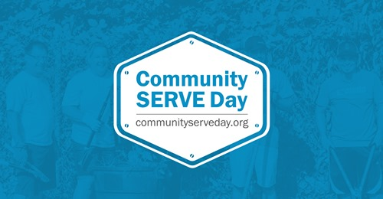
⭐️In order for CPMS to participate in Community Serve Day, we need a volunteer site leader or co-leaders!!⭐️
CSD will be held on Sunday, August 22nd from 9am-1pm.
The site leader helps to organize the volunteers, does a school walkthrough to review projects, picks up supplies for the school, and stays connected with the school's principal leading up to the event.
Interested or want more information? Visit this link.

Join Our Team Next Year!!!
PTA’ing is a team sport and we’re looking to build our team for next year!

Do you like making people happy? Does it make your heart sing when you see smiles? If you said YES, then we think you would make the PERFECT Staff Appreciation lead! Staff Appreciation helps us recognize the hard work and dedication of our CPMS staff. They host events throughout the year ranging from cute little “We Appreciate You” reminders to full on luncheon events with help from volunteers within our CPMS community. Would you like to learn more? Contact our President@ president@cpptsa.org!

Threads & Treads: LAST OPEN DAY JUNE 16th!
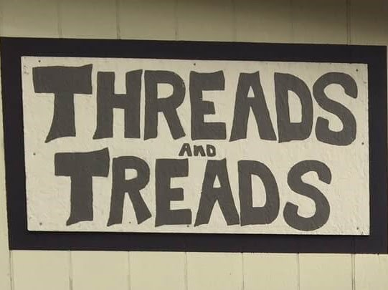
Our last open day is June 16th! We will reopen sometime in August - specific date TBD. We cannot accept donations after June 16th!!! So, get those donations in soon!!! They can be dropped off during our last two shopping days. Please do NOT leave donations at our doors over the summer!!

